Edward Esposito

9/18/2024

Data Analysis with Excel

The goal of this short project is to analyze a set of data strictly using Excel. This includes all steps of the data analysis process including visuals and dashboards. While normally I would use Excel along with other tools such as SQL, Python, or Tableau, I wanted to dive deeper into Excel and learn more about its capabilities, as it on its own can be a powerful tool. By doing an end-to-end project such as this, I have greatly expanded my proficiency of Excel. To do this I used a tutorial on YouTube which I reference below. The steps taken during this analysis are laid out below as well.

Steps:

1. Data Cleaning/ Setup
   * 1. Explore the data and check for misspellings, whitespaces, etc.
   1. Use Xlookup to bring the values for Customer Name, Email, and Country into the orders sheet.
      1. =XLOOKUP(C2,customers!$A$1:$A$1001,customers!$B$1:$B$1001,,0)
      2. =IF(XLOOKUP(C2,customers!$A$1:$A$1001,customers!$C$1:$C$1001,,0)=0,"",XLOOKUP(C2,customers!$A$1:$A$1001,customers!$C$1:$C$1001,,0))
   2. Use Index match to bring the values for Coffee Type, Roast Type, Size, Unit Price, and Sales into the orders sheet.
      1. =INDEX(products!$A$1:$G$49,MATCH(orders!$D2,products!$A$1:$A$49,0),MATCH(orders!I$1,products!$A$1:$G$1,0))
      2. This formula is lengthy. Because I feel it is not as readable as Xlookup, I would have rather used Xlookup for those columns. The advantage of the index match is that if It can be written once correctly it can be used in all of the columns while xlookup would need to be re-written for each column. While I would have used xlookup myself, I used the index match for the purposes of learning. In my opinion I would have rather kept it simple.
   3. Populate Sales Column
      1. =L2\*E2 (Unit Price\*Quantity)
   4. Give the full name for the coffee type
      1. Use =UNIQUE(I2:I1001) to get all the unique coffee types
      2. Use If Statements to check and populate for each coffee type.
         1. =IF(I6="Rob","Robusta",IF(I6="Exc","Excelsa",IF(I6="Ara","Arabica",IF(I6="Lib","Liberica",""))))
   5. Do the same for Roast Type
      1. =IF(J13="M","Medium",IF(J13="L","Light",IF(J13="D","Dark","")))
   6. Update date format
      1. dd mmm yyyy
   7. Add “kg” to the size column to specify the metric.
      1. 0.0 “kg”
   8. Remove Duplicates
   9. Convert sheet into Table.
2. Pivot Tables
   1. Create a pivot table. This will be for each month in each year the sales of each coffee type. Here is what it looks like: 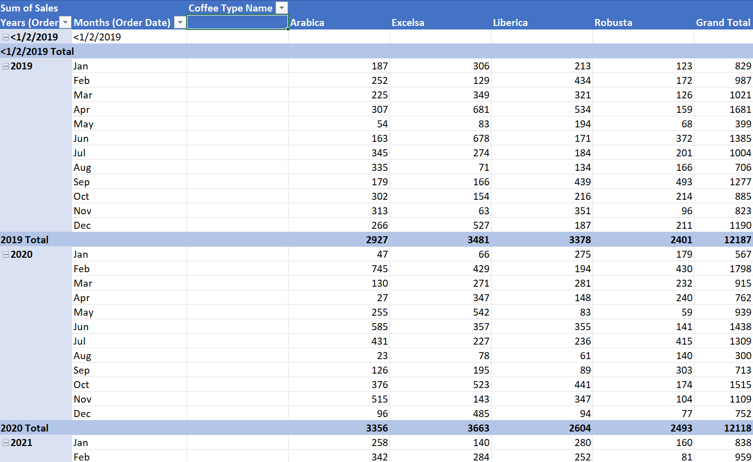
   2. Create Line Chart
   3. Create Timeline for Line Chart
   4. Create slicers for Loyalty, Roast Type, and Size
3. Copy the pivot table to another sheet and replace the current rows with Country.
   1. Create Bar Chart for the Country
4. Copy the pivot table to another sheet and replace the current rows with Customers.
   1. Filter for the top 5 customers by sum of sales.
   2. Create bar chart for top 5 customers.
5. Copy all Charts to a new sheet which will be the dashboard.
   1. Make sure all charts are connected.
   2. Arrange the charts.

Comments:

* This short project expanded my knowledge of excel, especially when working with charts. The main areas of focus regarding excel were formulas (xlookup, index match), filtering, sorting, pivot tables, charts, and creating a dashboard.
* The biggest challenge I faced in this project was an error in the xlookup and the charts showing blank values.
  + The xlookup error was solved by combing through the formula and discovering a missing comma.
  + The blank value shown in the charts was disabled through right clicking the charts and choosing not to show blank values. Note: There were no real blank values as they came from the grand totals and not the original data source. Therefore, I felt it was logical for blank values to be removed.

References: